Name:- shlok jagganath vaskar

STD:- sy.bsc.it

SUB:-

ROLL NO:-18096

Project name:-Domain name system

. . . . . 18069
Aim:- To write a Python program that performs DNS resolution by finding the IP address of a given domain name and performing reverse DNS lookup to find the domain name of a given IP address.

Explanation:-
DNS stands for Domain Name System, which works like the Internet’s phonebook.
Humans use website names (like google.com), but computers use IP addresses (like 142.250.193.78) to communicate. DNS converts domain names into IP addresses and IP addresses back into domain names.

In this Python program:
The socket module is used for DNS functions.
socket.gethostbyname(domain)
→ Converts a domain name into its corresponding IP address.
socket.gethostbyaddr(ip_address)
→ Finds the domain name linked to a given IP (reverse DNS).
A simple menu-driven program is created to let the user choose between:
1. Domain → IP lookup
2. IP → Domain lookup
3. Exit program
Error handling is added to manage invalid domains or unreachable IPs.
This program helps understand how DNS works on networks and how Python can be used for network-related tasks.

Shlok vaskar SIWS COLLEGE MINOR PRACTICAL
18069
PROGRAM:-
import socket
def dns_lookup():
print("---- DNS Resolver ----")
while True:
print("\n1. Find IP address of a domain")
print("2. Find domain name from IP")
print("3. Exit")
choice = input("Enter your choice: ")

if choice == '1':
domain = input("Enter domain name (e.g., google.com): ")
try:
ip = socket.gethostbyname(domain)
print(f"IP address of {domain} is: {ip}")
except socket.gaierror:
print("Invalid domain or network error.")

elif choice == '2':
ip_address = input("Enter IP address (e.g., 8.8.8.8): ")
try:
domain = socket.gethostbyaddr(ip_address)
print(f"Domain name for IP {ip_address} is: {domain[0]}")
except socket.herror:
print("No domain found for this IP.")
18069
elif choice == '3':
print("Exiting DNS program.")
break
else:
print("Invalid choice! Try again.")

if __name__ == "__main__":
dns_lookup()

OUTPUT:-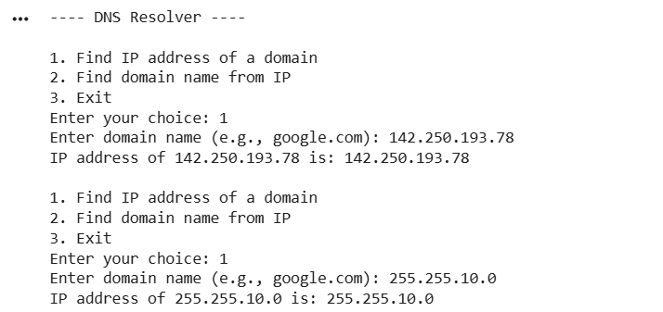

Shlok vaskar SIWS COLLEGE minor practical

18069
Conclusion:-
The Python program successfully performs DNS resolution by converting domain names to IP addresses and IP addresses to domain names. This experiment demonstrates the working of DNS and shows how easy it is to implement basic network operations using Python’s built-in socket module. DNS is essential for internet communication, and this practical provides a clear understanding of how name resolution occurs behind the scenes.

Shlok vaskar SIWS COLLEGE minor practical

